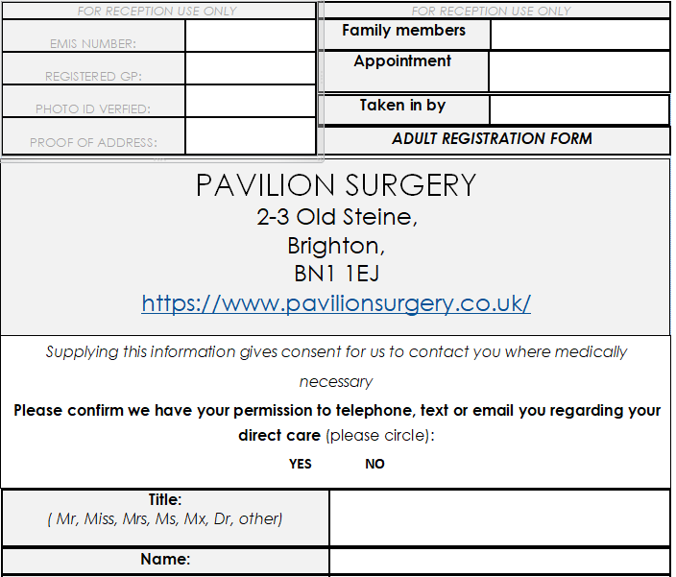

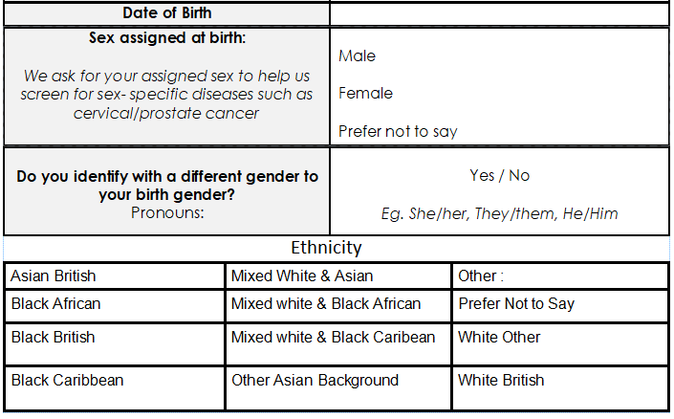

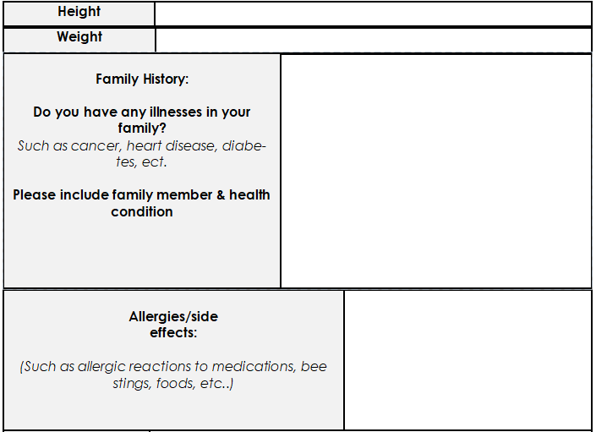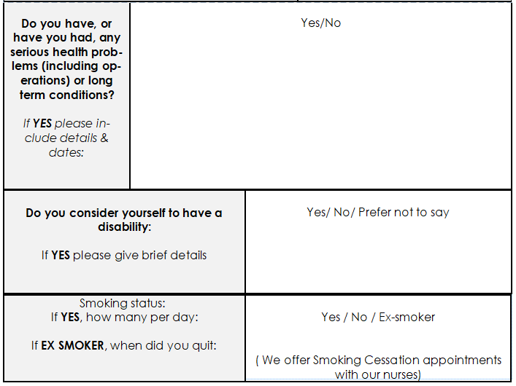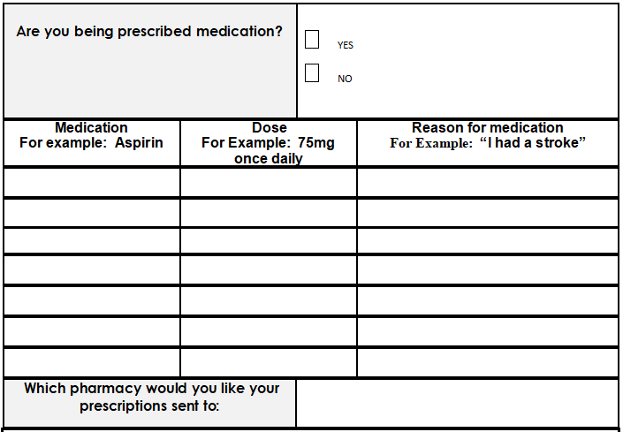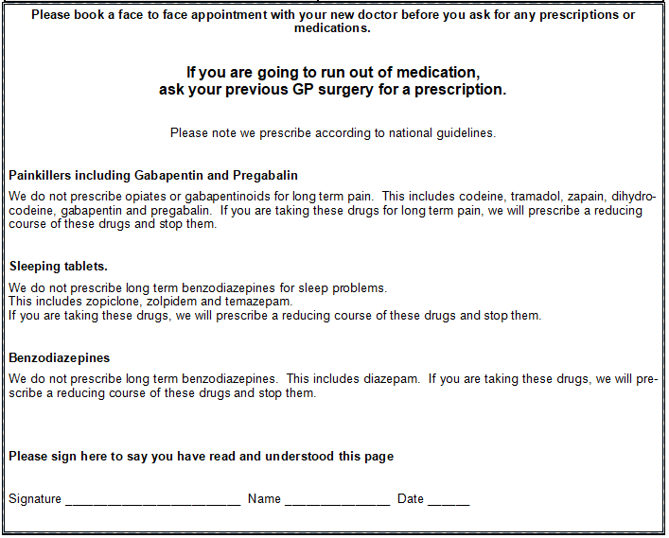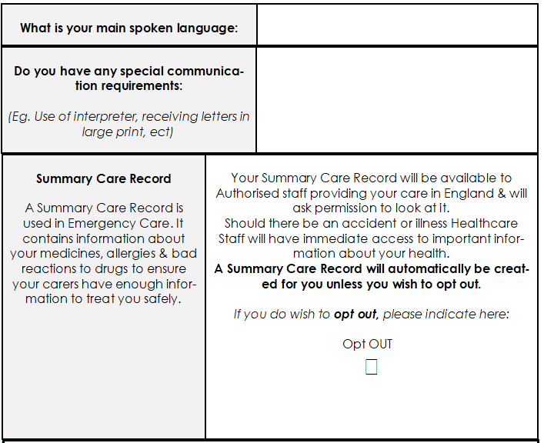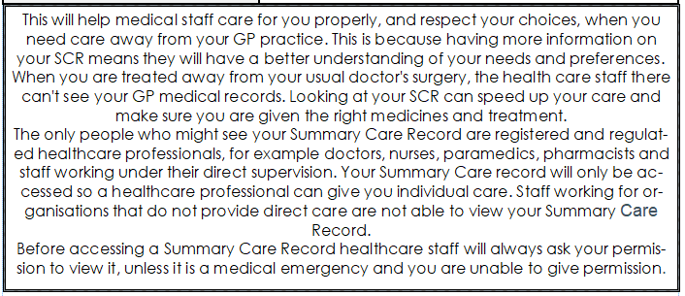

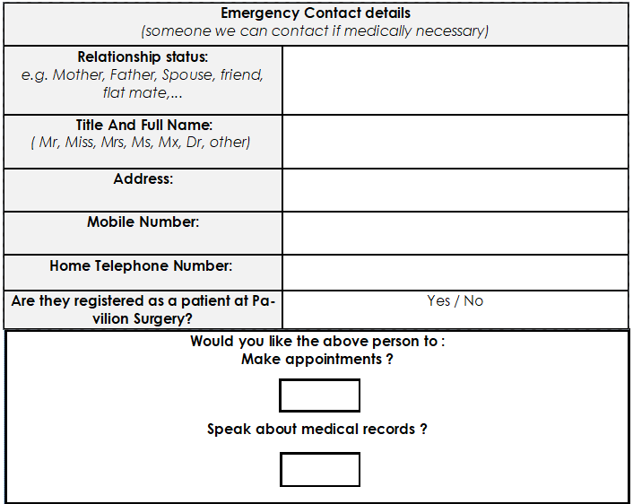

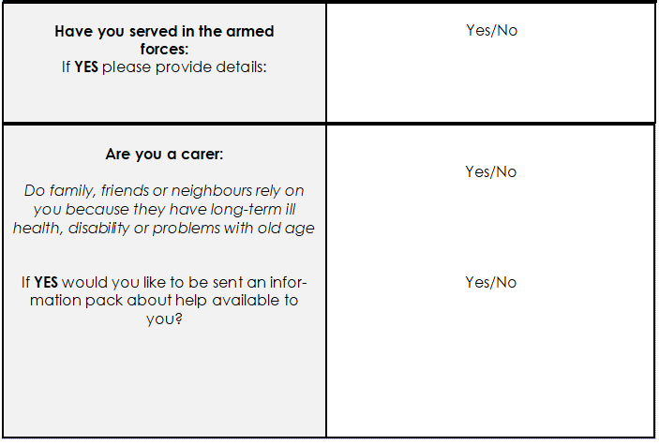

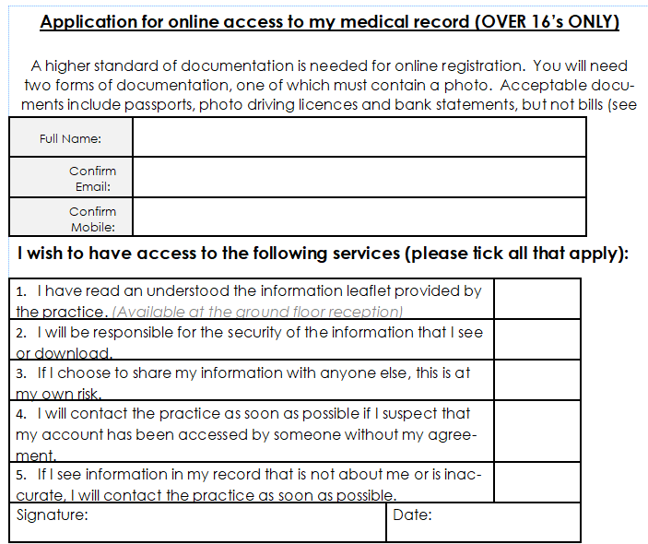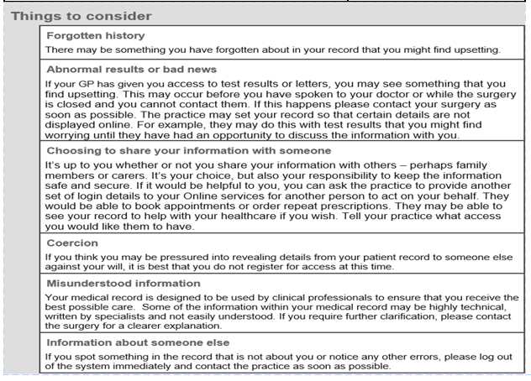

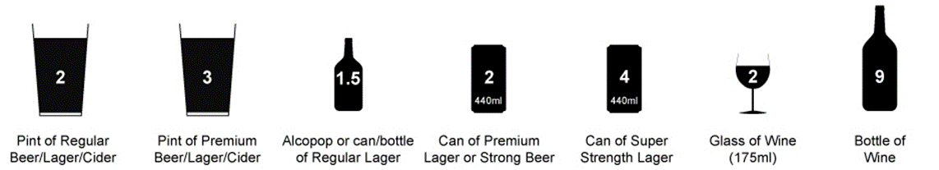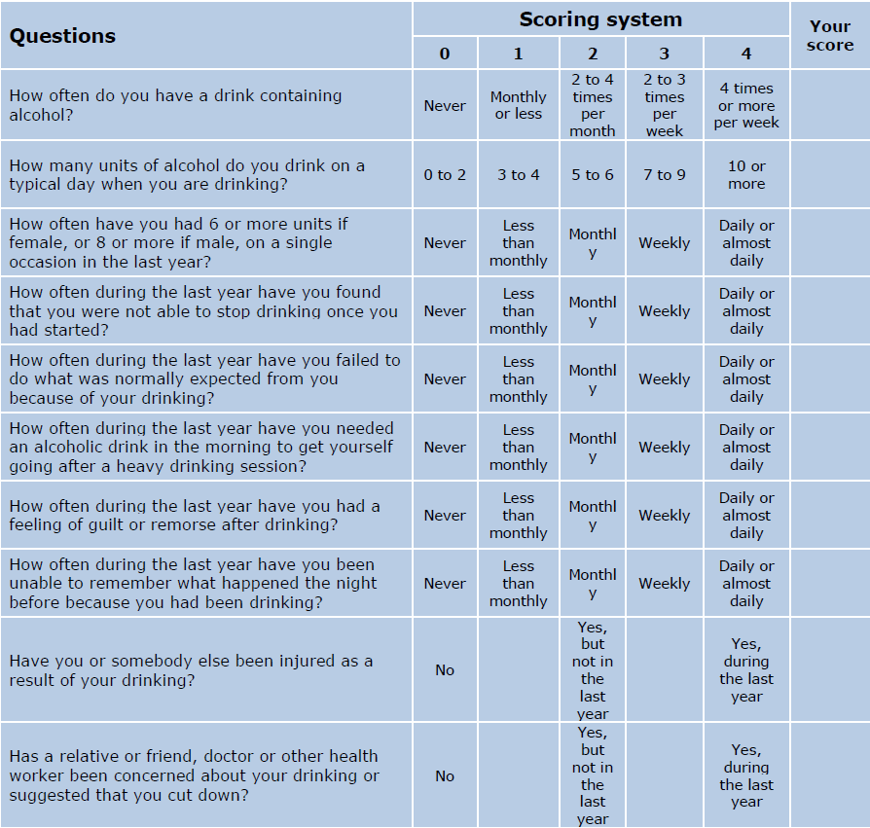

Scoring:

A total of 5+ indicates increasing or higher risk drinking. An overall total score of 5 or above is AUDIT-C positive.

If your score is higher than 8 and would like ***Free NHS Help*** for alcohol problems please call the Surgery on 01273 685588 or contact: [www.changegrowlive.org.uk](http://www.pavilions.org.uk) who offer a drop-in service at:

Richmond House,

Richmond Road,

Brighton BN2 3FT

Tel: 01273 731 900

Mon-Tues-wed-Fri 9am-5pm/Thursday 9am-7pm & Saturday 10am-1pm.